

Practices for Secure Software Report

Table of Contents
Practices for Secure Software Report 1
Document Revision History 3
Client 3
Developer 4
1. Algorithm Cipher 4
2. Certificate Generation 4
3. Deploy Cipher 5
4. Secure Communications 5
5. Secondary Testing 6
6. Functional Testing 7
7. Summary 7
8. Industry Standard Best Practices 8

Document Revision History

Version | Date | Author | Comments
1.0 | 6/21/2026 | David Cardimen | Initial Project Two submission

Client



Developer
David Cardimen

Algorithm Cipher

The SHA-256 hashing algorithm was added to the Artemis Financial application to create a secure checksum for data verification. This algorithm converts data into a unique hash value that can be used to confirm the integrity of the information.
SHA-256 helps improve security because any change made to the original data results in a completely different hash value. This makes it possible to identify whether information has been altered, either intentionally or accidentally.
For this project, the application was modified to generate and display a SHA-256 checksum through the web interface. This allows users to verify that the data remains accurate and unchanged, helping to maintain the integrity and reliability of the application.

Certificate Generation
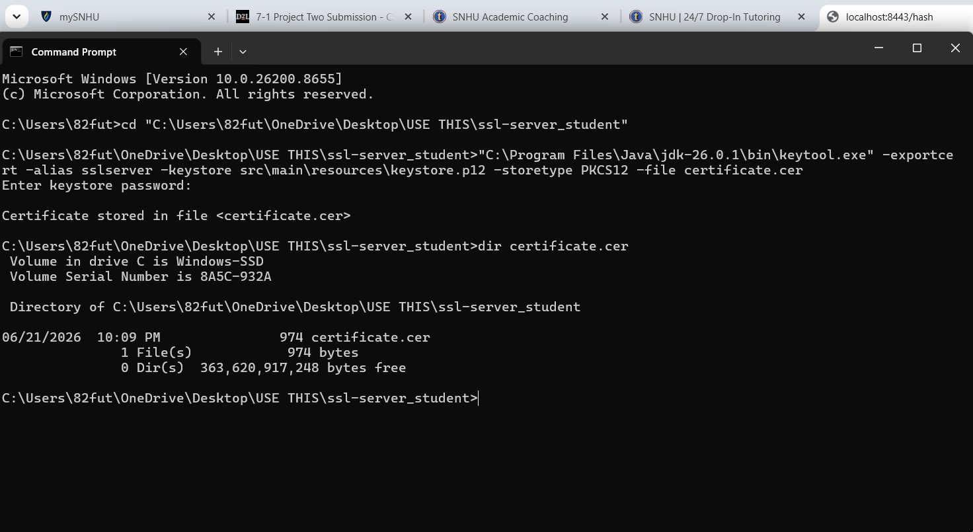

Deploy Cipher
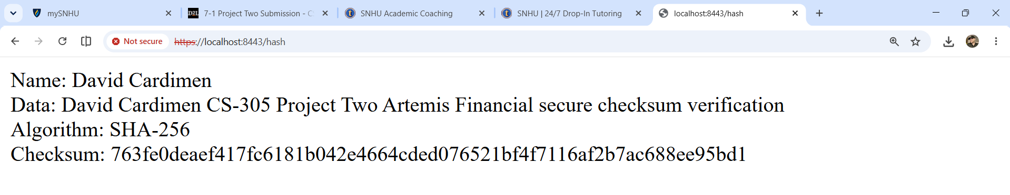

Secure Communications
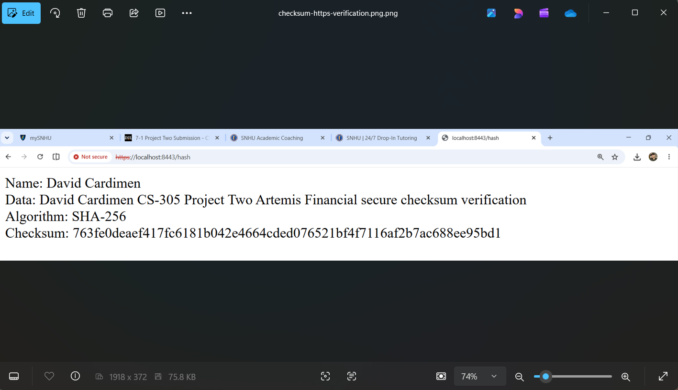

Secondary Testing
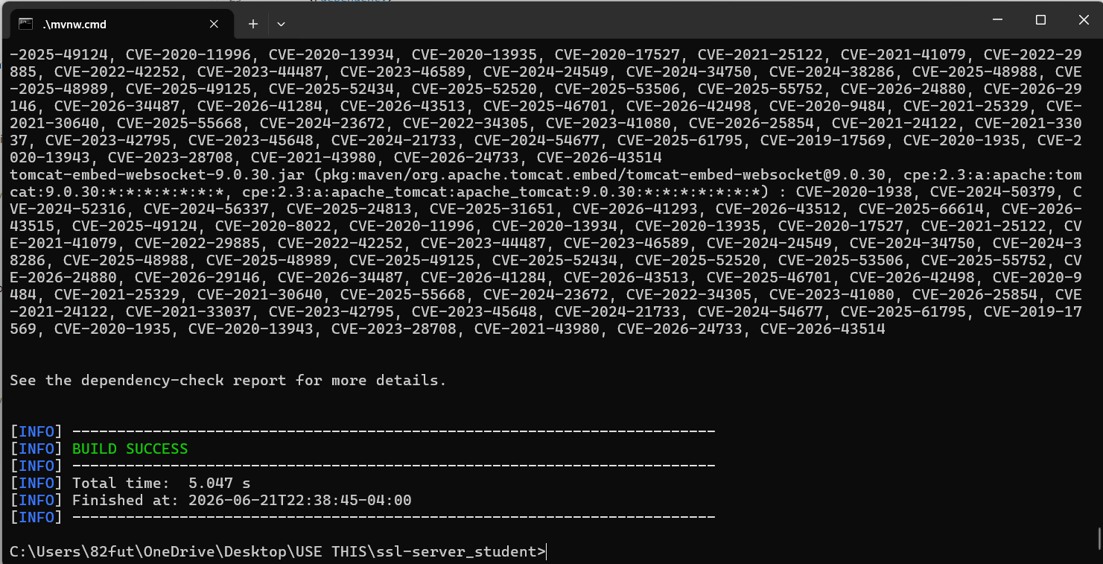
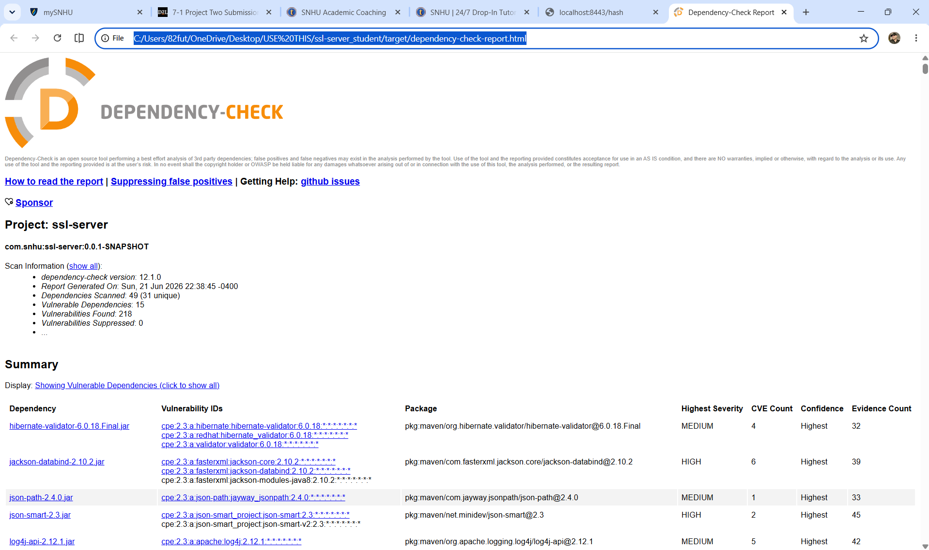

Functional Testing


Summary

Throughout this project, I improved the security of the Artemis Financial application by implementing secure communication protocols and data integrity controls. A self-signed certificate was generated and configured to enable HTTPS communication, helping protect data transmitted between the client and server. The SHA-256 hashing algorithm was also implemented to generate checksums and verify that data had not been altered during transmission.
In addition, I performed a dependency analysis using the OWASP Dependency-Check Maven plugin to identify potential vulnerabilities within third-party libraries. The generated report provided valuable insight into security risks associated with project dependencies. After completing the required configuration updates and testing procedures, the application successfully built and executed without errors. This project reinforced the importance of secure coding practices, vulnerability assessment, encryption, and secure communications in developing reliable software applications.

Industry Standard Best Practices

This project applied several security practices that are commonly used throughout the software industry to help protect applications and the data they process. Secure communication was established through HTTPS, which encrypts information exchanged between the client and server. A certificate was generated and configured to support encrypted connections and improve the overall security of the application.
The project also used the SHA-256 hashing algorithm to verify data integrity by generating a unique checksum for submitted information. In addition, OWASP Dependency-Check was used to scan project dependencies and identify known vulnerabilities in third-party libraries. Regularly reviewing dependencies and addressing security risks is an important part of maintaining secure software. By combining encryption, hashing, and vulnerability analysis, this project followed recognized security practices that contribute to building more reliable and secure applications.

